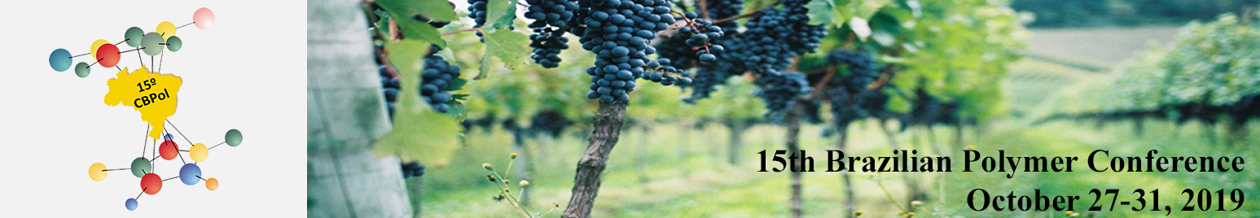

TITLE
CAPITAL LETTERS, TIMES NEW ROMAN 14, BOLD, CENTERED PARAGRAPH, SINGLE SPACE
Write the name of authors following the example below, indicating with *. Example:
Louis T. Shoemaker¹, Rose S. A. Garden² and Bruce Reedwood¹*
(Times New Roman 10, bold, centered paragraph, single space)
Insert here the author(s) affiliation(s). Write the e-mail of the author to whom correspondence should be addressed. Ex.:
1 – Department of Materials Engineering, University of São Paulo (USP), São Paulo, SP, Brazil corresponding_author@server.com.br
2 – Department of Materials Engineering (DEMa), Federal University of São Carlos (UFSCar), São Carlos, SP, Brazil
(Times New Roman, 10, italic, centered paragraph, single space)

Abstract - Insert here an abstract of maximum 1000 characters, single paragraph.
(Times New Roman 10, single space, justified paragraph)
Keywords: Insert here up to 5 keywords. Maximum of 40 characters for each keyword.
(Times New Roman 10, italic)

Introduction (Times New Roman 12, bold)
Write here the text in Times New Roman 12, single space line, justified paragraph, 1 column.
References should be indicated throughout the text as “...word [1-3, 5].”

Experimental (Times New Roman 12, bold)
If there is a subtitle, write it in Times New Roman 12, italic
Write here the text in Times New Roman 12, single space line, justified paragraph, 1 column.

Results and Discussion (Times New Roman 12, bold)
Write here the text in Times New Roman 12, single space line, justified paragraph, 1 column.

Tables, Figures and Equations should to be inserted distributed throughout the text.

Table 1 (Times New Roman 12, bold) – Insert the table after its title in Times New Roman 11, single espace line, justified paragraph, 1 column. If necessary, insert notes below the table in Times New Roman 11, single space line, justified paragraph, 1 column. In the text write Table 1.

Figure 1 (Times New Roman 12, bold) – Write the legend below the Figure, in Times New Roman 11, single space line, justified paragraph, 1 column. In the text write Fig 1.

Equations – Insert equations numbered sequentially between brackets. In the text write Eq. 1
$\text{Y=aX+b}$ (1)

Conclusions (Times New Roman 12, bold)
Insert the text in Times New Roman 12, single space line, justified paragraph, 1 column.

Acknowledgements (Times New Roman 12, bold)
Insert the text in Times New Roman 12, single space line, justified paragraph, 1 column.

References (Times New Roman 12, bold)
Follow the examples in Times New Roman 12, single space line, justified paragraph, 1 column.

- For articles: R. Ling; M. Yoshida; P.S. Mariano J. Org. Chem. 1996, 61, 4439.
- For thesis: F. H. Dutra, Ph.D. Thesis, University of Southampton, 1995.
- For books without editor: E. Haslam, Shikimic Acid Metabolism and Metabolites, John Wiley & Sons, New York, 1993.
- For books with editor: J. G. Buchanan; H. Z. Sable in Selective Organic Transformations, B. S. Thyagarajan, Ed.; Wiley-Interscience, New York, 1972; Vol. 2, 1-95.
- For patents: F. R. Lyle, U.S. Patent 5 973 257, 1985; Chem. Abstr. 1985, 65, 2870.
- For proceedings: O. Barbosa in Proceedings of 10th Brazilian Catalysis Conference, Salvador, 1999, Vol. 1, 343.

Number of pages: minimum of 3 pages and maximum of 5 pages.
Maximum size of the file: 4 MB.

